Assignment 2 Report

Table of Contents

1. Introduction ........................................................................... 1
2. How I Used the Five Layers of UX Design ............................ 1  
   2.1 Strategy: Why AZoom Exists ............................................. 1  
   2.2 Scope: What I Built (and What I Didn’t) ......................... 2  
   2.3 Structure: How Users Move Through the Site .................. 2  
   2.4 Skeleton: Layout and Clarity ........................................... 3  
   2.5 Surface: Colors, Icons, and Visual Feel .......................... 4
3. Key Features That Bring the Rental Journey to Life ............ 5
4. How It All Works Behind the Scenes ................................... 6
5. Final Thoughts ...................................................................... 7
6. Interactive Demo ................................................................. 7

**1. Introduction**

This report explains the design and implementation of the AZoom Car Rental website, built using only HTML, CSS, and JavaScript. When I started building the AZoom website, my main goal was simple: to create a rental experience that makes choosing an electric vehicle (EV) feel easy, smart, and convenient, especially for people in Singapore who care about the environment and low cost.

I used HTML, CSS, and JavaScript without a backend database, but instead using the browser’s localStorage to store users and their bookings.

This report will cover how I applied the five layers of UX design to design the website and the visual and interaction choices I chosen.

**2. Applying the Five Elements of UX Design**

2.1 Strategy

The strategy layer defines why the product exists and the targeted user.

Business Goal: Position AZoom as Singapore’s go-to EV rental service by emphasizing cost savings “EV rentals up to 30% cheaper” and environmental benefits “zero-emission vehicles”.

User needs: Local customers and tourists want a simple, secure, and mobile-friendly way to rent EVs without hidden steps or complex forms.

The 2 focuses shaped every page:

The homepage with a bold headline: “Experience Singapore with Eco-Friendly Mobility”.

The “Why Choose AZoom?” section uses clear, benefit-driven language

EVs are prioritized in the fleet e.g. Deepal S07, BYD Seal 6 and AION Y Plus, over hybrids or gasoline cars.

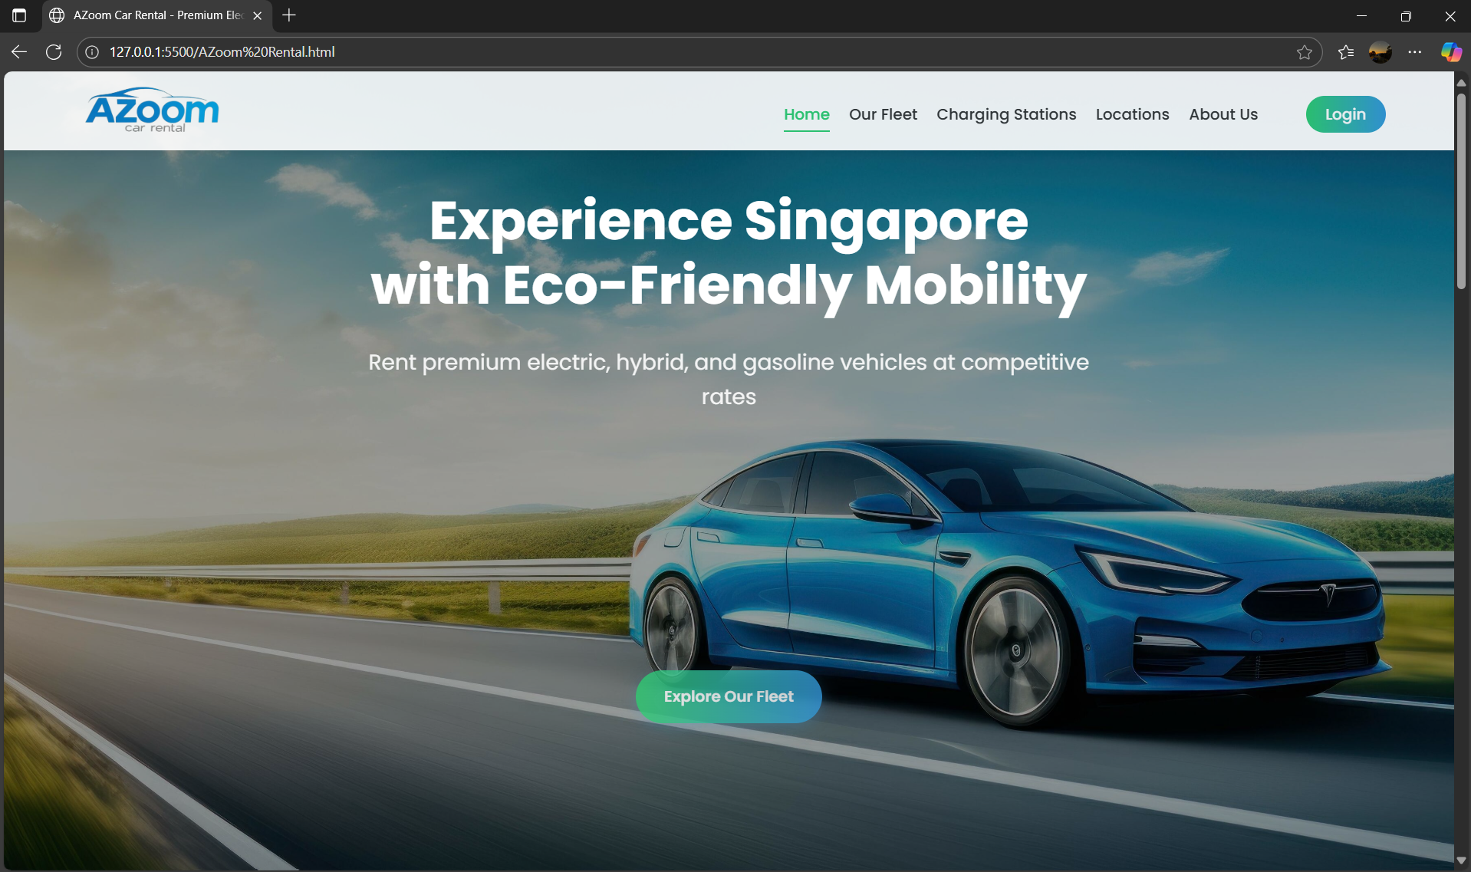

Figure 1: AZoom Homepage

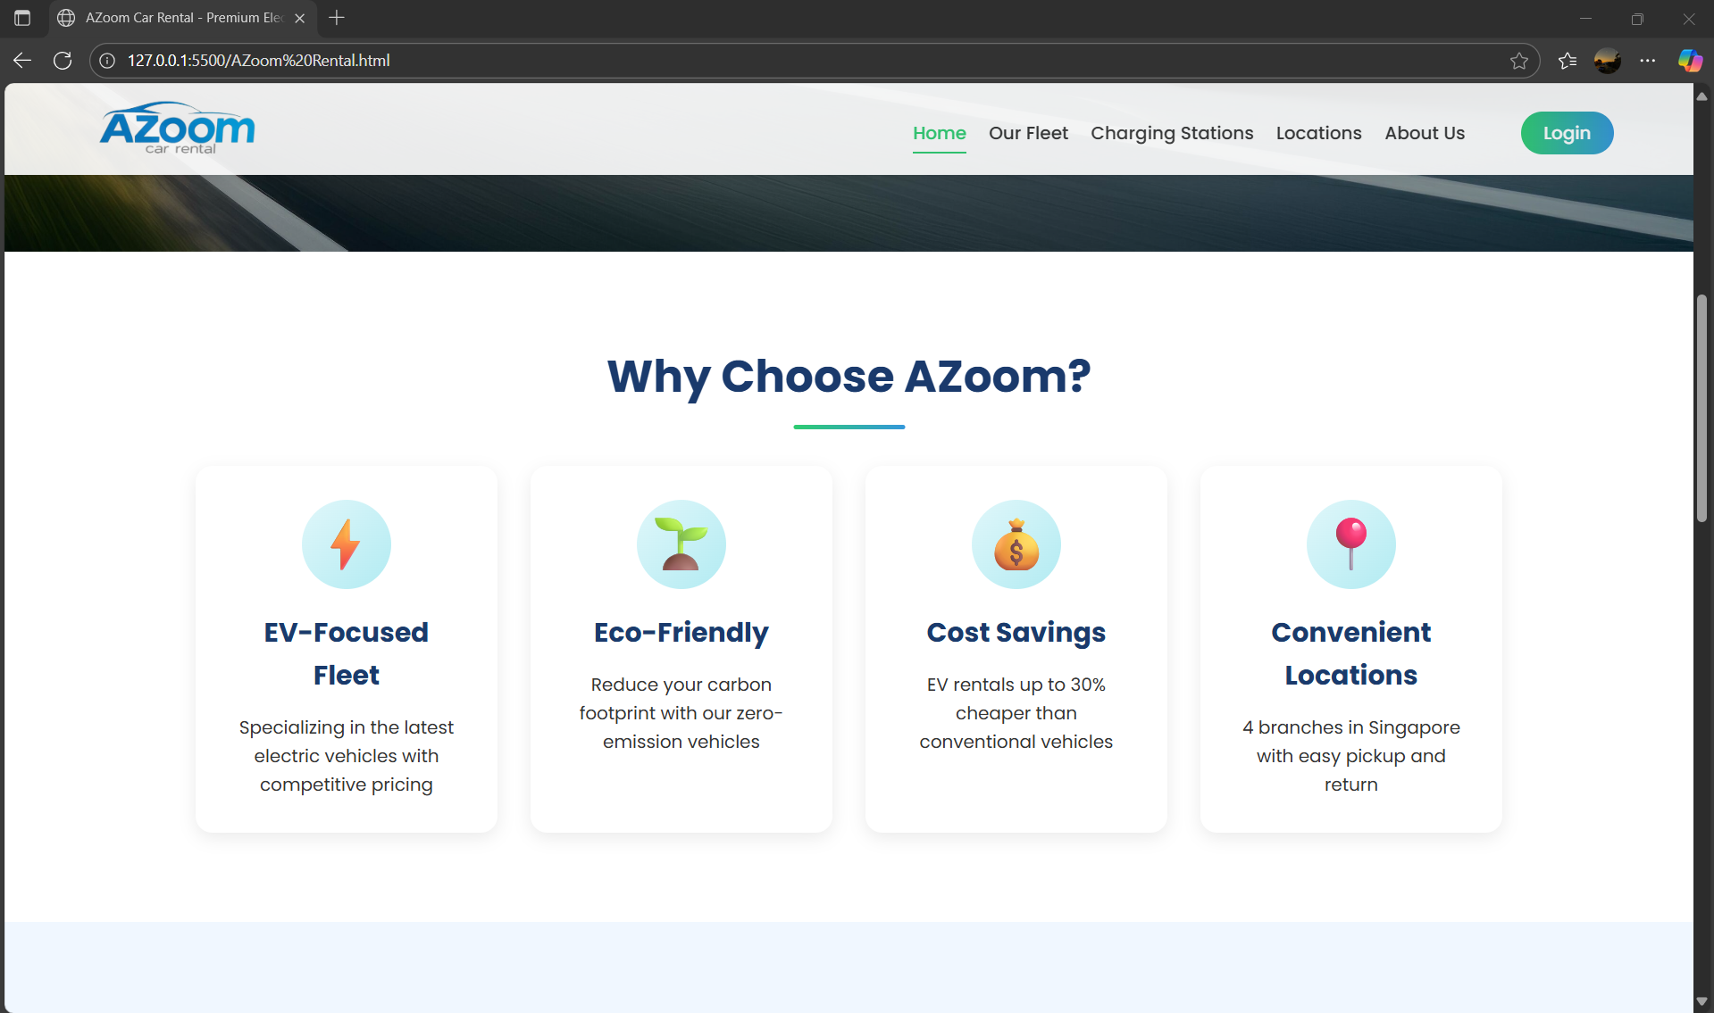

Figure 2: Why Choose AZoom?

**2.2 Scope**

The scope layer defines what features are included.

To keep the prototype focused and achievable, I implemented only essential frontend features

* User authentication (login/register/logout)
* Fleet browsing with 34 vehicles (EVs, hybrids, gasoline)
* Reservation system with form validation, car plate/reservation ID generation, and cost calculation
* My Reservations dashboard with real-time status (pending → collected → returned)
* Interactive modals for collection checklists, damage reporting, and cancellations

**2.3 Structure**

The structure layer defines how users move through the site

I designed a linear rental flow:

* Home → Learn about AZoom’s mission
* Our Fleet → Browse and select a vehicle
* Reservation → Enter details and confirm booking
* My Reservations → Manage, collect, return, or cancel

Navigation is consistent across all pages:

* A responsive top bar with hamburger menu on mobile
* Dynamic auth state: When logged in, “Login” disappears and is replaced by “Hi, [Name]”, “My Reservations”, and “Logout”
* Auto redirection: Users not logged in are redirected from reservation.html and myreservations.html to the login page



Figure 3: Logged out state



Figure 4: Logged In state

**2.4 Skeleton**

The skeleton layer defines the layout and information hierarchy.

Key layout decisions:

* Card-based design: Each car, reservation, and benefit is in a card with clear headings, specs, and actions
* Form grouping: Reservation form fields are grouped logically (personal info → car details → payment → license)
* Status visibility: In “My Reservations”, each booking shows its status badge (pending/collected/returned) in a colored box for instant recognitio44n
* Mobile-first spacing: Padding, font sizes, and button heights are optimized for touch

For example, the reservation confirmation screen uses a clean list layout (<div class="summary-item">) to display:

* Reservation ID
* Car plate
* Pickup/return times
* Total cost

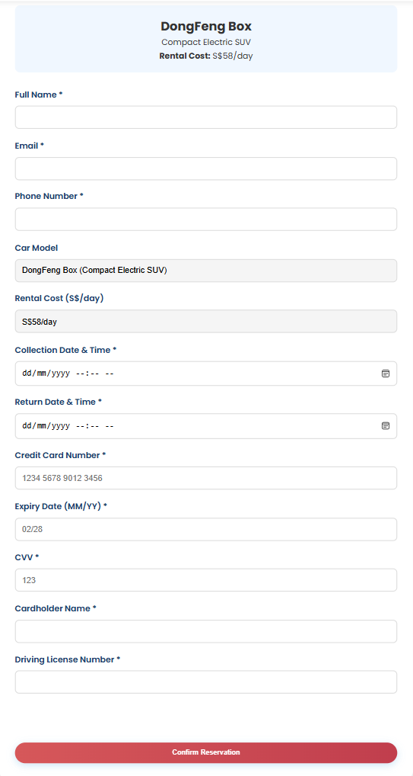

Figure 5: Reservation Form

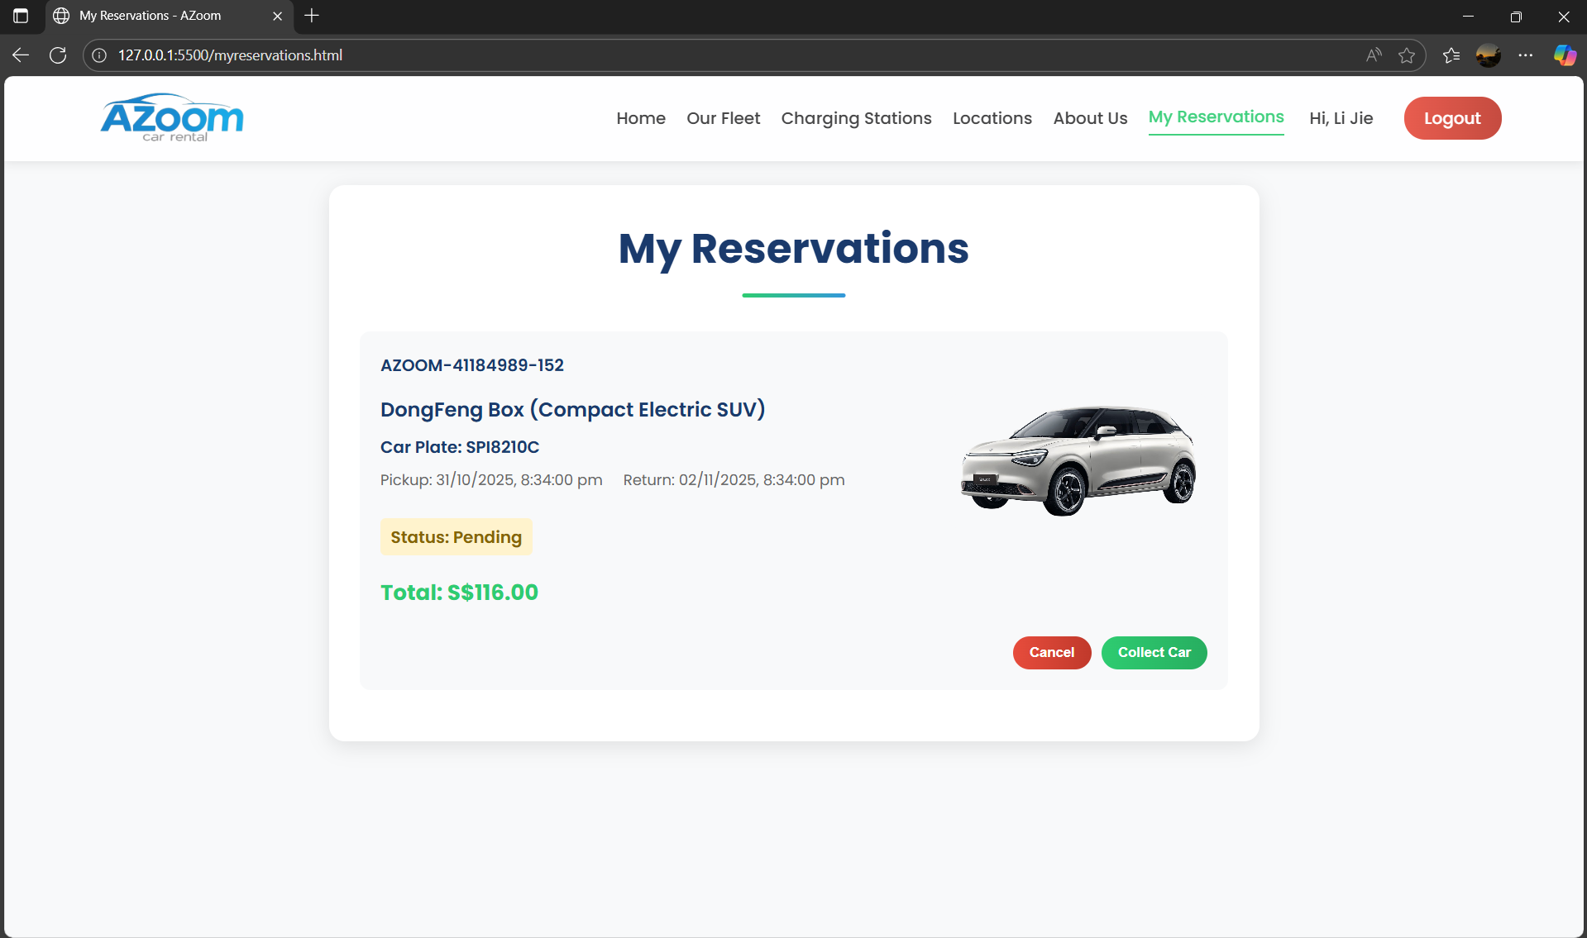

Figure 6: My Reservations